C# Database Project Concepts

Connecting a project to a SQL Server database (be sure to view the slides below on setting up / using the Server Explorer):

Example of a manual connection (put statements in code where appropriate):

using System.Data.SqlClient;

SqlConnection conn = new SqlConnection();

//replace server name and database name

conn.ConnectionString = "Server = *servername*; Database = *databasename*; Trusted_Connection = yes;";

conn.Open(); //open connection

SqlDbDataAdapter da = new SqlDbDataAdapter("SELECT * FROM mytable", conn); //tie data adapter to the actual database

Dataset ds; //optionally, a dataset can be created and populated

da.Fill(ds, "MyDataSet"); //this dataset now holds all the rows from the query above

Example of a SELECT statement:

string sel = "SELECT * FROM mytable WHERE mykey = mykeyvalue”; //sql select string

SqlCommand command = new SqlCommand(sel, conn); //make a command from the string, using your connection

SqlDataReader sdr = command.ExecuteReader(); //use the command to create a data reader, which will contain the rows

if (sdr.HasRows) //boolean property: check to see if any rows were returned to the reader

sdr.Close(); //be sure to close the reader

Example of an INSERT statement:

string ins = "INSERT INTO mytable VALUES(myvalue1, myvalue2, etc.)"; //sql insert string

SqlCommand command = new SqlCommand(ins, conn); //make a command from the string, using your connection

int numRows = command.ExecuteNonQuery(); //use the command to insert the row

if (numRows > 0) // check to see if/how many rows were inserted (should be a value of 1)

Example of an UPDATE statement:

string upd = "UPDATE mytable SET mycolumn1 = myvalue1, mycolumn2 = myvalue2 WHERE mykey = mykeyvalue“; //sql update string

SqlCommand command = new SqlCommand(upd, conn); //make a command from the string, using your connection

int numRows = command.ExecuteNonQuery(); //use the command to update the row

if (numRows > 0) // check to see if/how many rows were update (should be a value of 1)

Example of a DELETE statement:

string del = "DELETE * FROM mytable WHERE mykey = mykeyvalue“; //sql delete string

SqlCommand command = new SqlCommand(del, conn); //make a command from the string, using your connection

int numRows = command.ExecuteNonQuery(); //use the command to delete the row

if (numRows > 0) // check to see if/how many rows were delete (should be a value of 1)

Example of using a SqlDataReader to sequentially loop through multiple rows:

string sel = "SELECT * FROM mytable WHERE mykey = mykeyvalue”; //sql select string

SqlCommand command = new SqlCommand(sel, conn); //make a command from the string, using your connection

SqlDataReader reader = command.ExecuteReader();

if (reader.HasRows) //if there are rows to process

{

while (reader.Read()) //loop through until eof

{

//logic to process each row returned

//reader.GetValue(?) //to access a specific column of the row replace ? with index of column

}

}

reader.Close(); //always close the reader when done

Miscellaneous:

* Consider making your database objects public static variables so that multiple forms can use them.
* Open and close connection when your program execution requires it.
* Be sure to place database statements in try/catch to catch potential exceptions.
* Important to use the debugger to determine which statement might be in err.
* More than one DataAdapter can be used (if needing to process multiple tables)

**Using SQL Server Explorer to set up a SQL Server database that your project will connect to:**

First, verify that your SQL Server is running. Use SQL Server Configuration Manager, located in your Microsoft SQL Server 2012 folder.

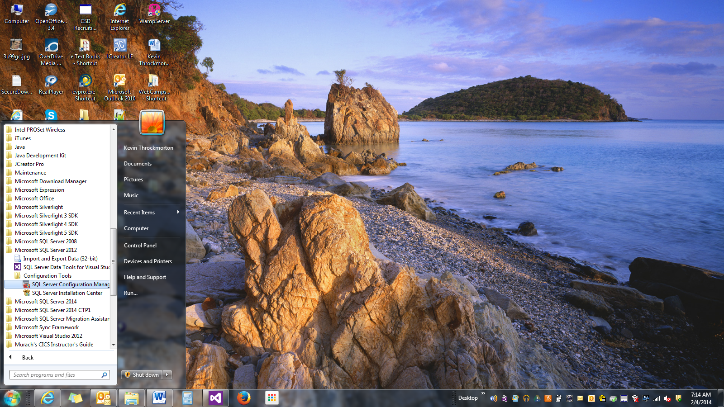

Make sure SQL Server says running, and if not, right click and start it.

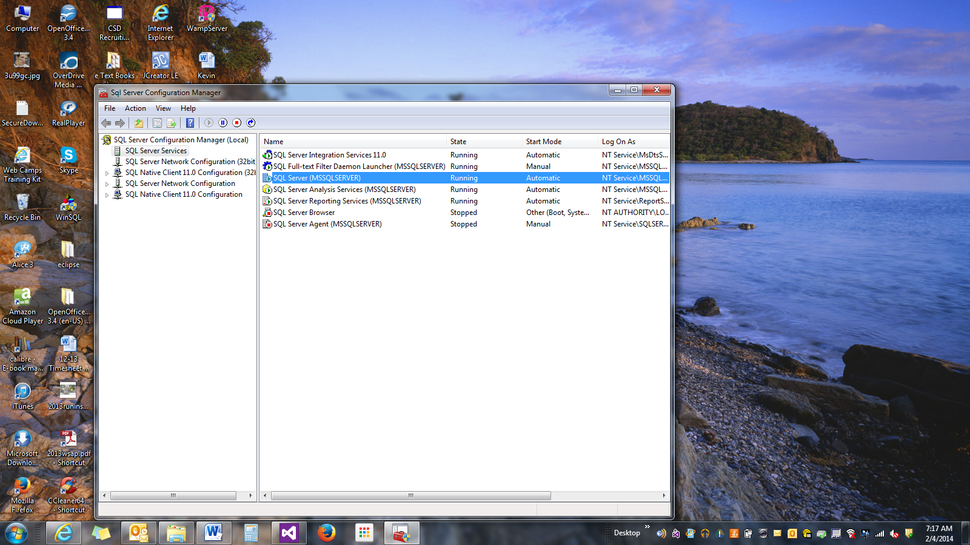

After your project has been initiated, open SQL Server Explorer by clicking View.

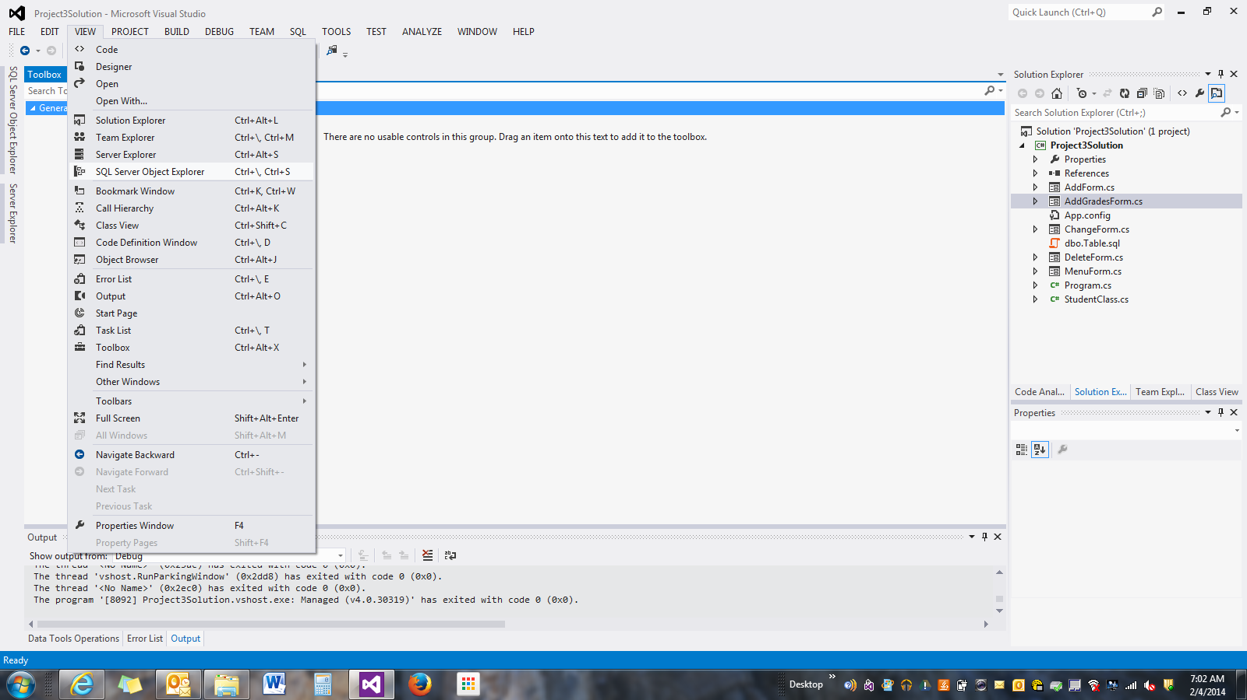

Your server name should be your computer name by default. Notice my server name is PC-KTHROCKM. This will be one of the arguments on your connection string when connecting to your database in your project.

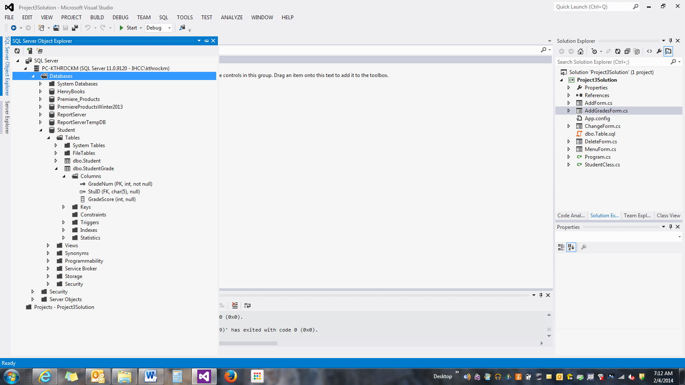

To create a database, right click on Databases, then Add New Database. Give it a name.

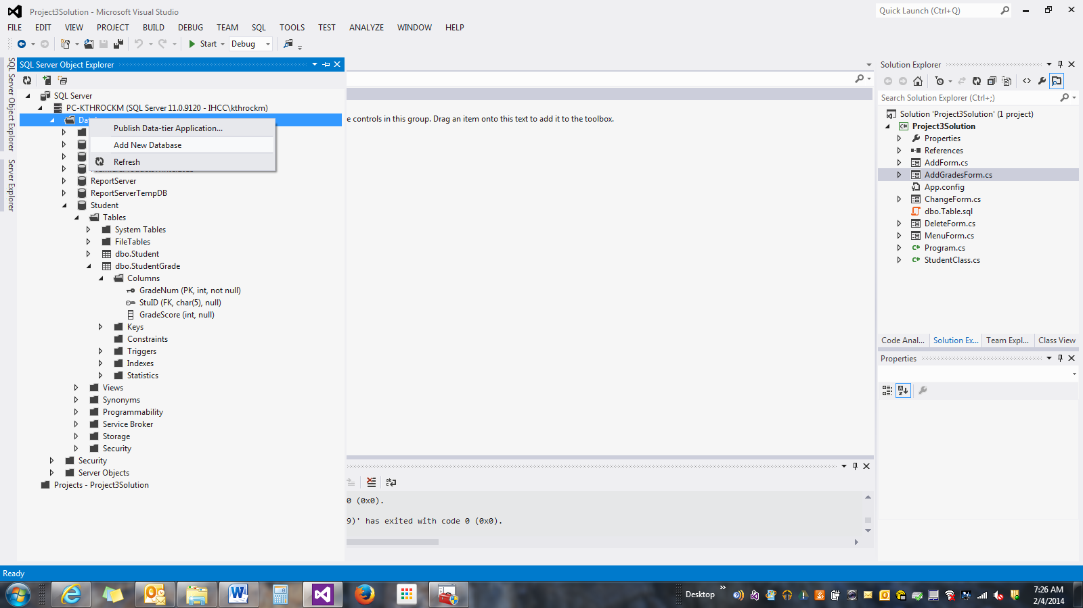

To add a table to the database, expand your new database, right click on Tables, then Add New Table.

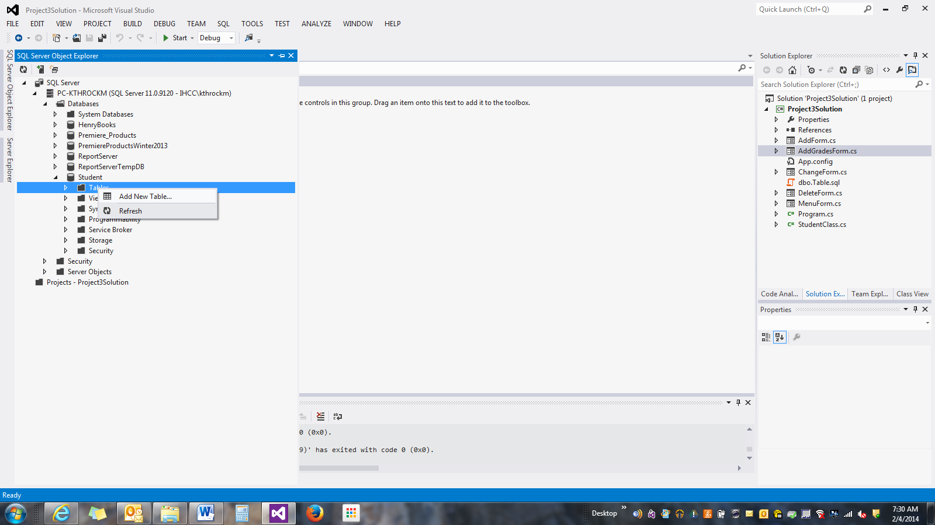

Once in table designer, build the columns that are required for this table. Notice how the CREATE TABLE statement gets coded automatically for you as you design. I prefer to define any **Foreign Keys and Check Constraints** by typing them directly into the Transact-SQL (T-SQL) statement. When your design/code is finished, click the Update button, located just above the Name field in the design. Be sure to Google some SQL Server web sites for specific syntax on the CREATE TABLE statement.

